How to Use Send in Blue

**Creating Email Campaigns**

1. Start by creating a contact list

Click on the "Import all of your contacts" option.

2. To properly import data containing special characters, please ensure your files are saved as a CSV (comma delimited) or (comma separated values) file with the extension: .csv.

**Setup Campaign name**

*Campaign name*

*Subject*

*From name*

*Sender email*

Drag & Drop Editor: Create a mobile-friendly (responsive) email by dragging and dropping text blocks, images, buttons and other design elements to create a beautiful email.

Rich Text Editor: Create simple text emails using a WYSIWYG (What-you-see-is-what-you-get) editor.

Paste Your Code: Paste your own HTML code, which should be created by a design professional

**Send or schedule your campaign**

Step 4: Send or schedule your campaign

You have three choices:

Send it now (Note: your first campaign will send once your account has been validated.)

Schedule for a specific time

Send it at the best time - select a date and let SendinBlue send at the optimal time to engage each contact

**Creating and Email Campaign**

1. Setup your campaign

1.1 Campaign name

This element is not visible to your recipients but can be useful for organizing your campaigns within SendinBlue.

1.2 Subject:

This will determine whether your contacts decide to open your email.

1.3 Sender Email and From Name:

These allow your recipient to quickly identify you. They need to inspire confidence to encourage recipients to open your email.

**Build Your Campaign**

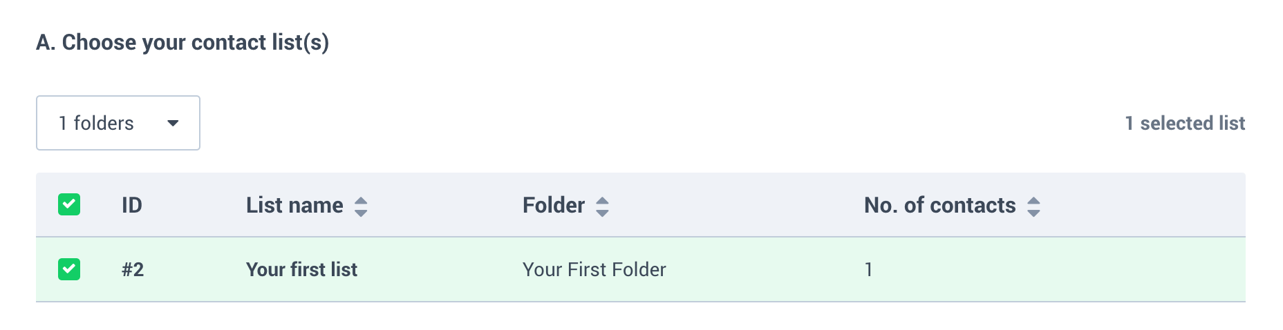

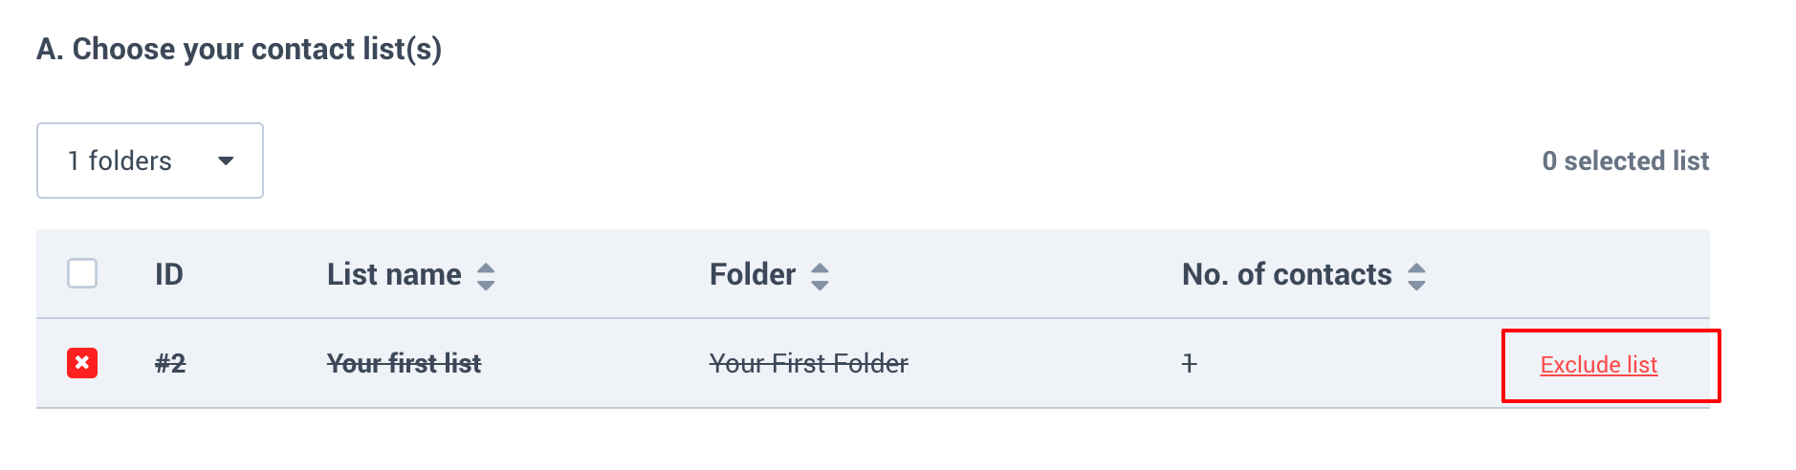

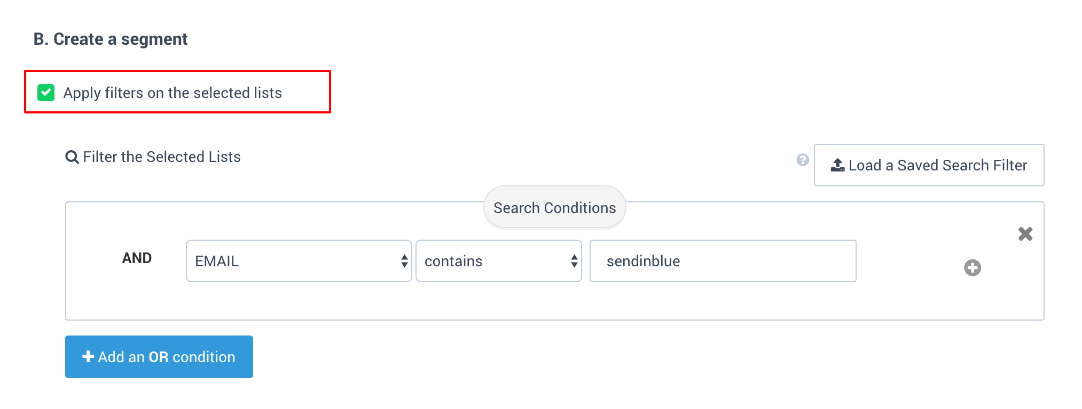

**Confirm**



**User Journey**

**My account Dashboard -> Login page ->**